To solve the following problem (Eq. (20) of “The Constrained Laplacian Rank Algorithm for Graph-Based Clustering”)

,

where , the paper proposed to use Newton’s method. Specifically, since the constraint  holds, they define the following function w.r.t. 

.

Then,  should be the root of function .

But  is not differentiable at the point  !!! Why Newton’s method can solve svm with hinge loss?

Exhaust search strategy is available. Suppose we solve a similar form of



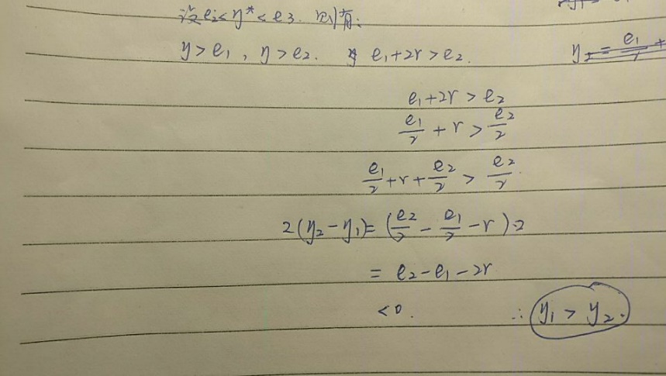

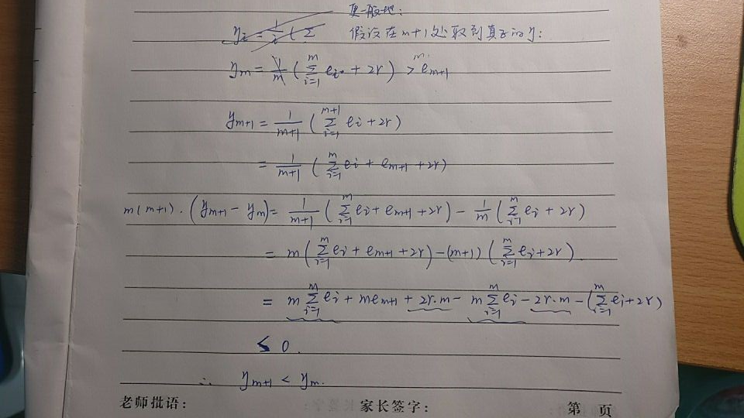

\eta monotonically decreases from the front to the end! Different from the previous prediction, hau~

